**HUMAN & COMPUTER INTERACTION LAB**

**PROJECT DOCUMENTATION**

Nama : Ong, Cornellius Jason Fernando

NIM : 2802540572

Kelas : PPTI 21

1. Introduction:

This project is a website created for the newly launched game, *Palorant*. Set in a near-future world, the game features a diverse roster of Agents, each with their own unique abilities. Developed by Giot, the game has quickly captured the attention of players, but many are still getting familiar with its mechanics. This website aims to guide new players, offering essential information about the game and a dedicated section for reporting bugs.

1. **Project Structure:**
2. ./documentation (contains local copy of the project)
3. ./fonts (contains list of the used fonts in this project)
4. ./images (contains assets used for the project)
5. ./figma (contains figma file)
6. ./maps-image (contains list of assets used for maps.html)
7. ./scripts (contains scripts js used for the project)
8. ./styles ( contains css file used for this project)
9. ./videos ( contains video asset for the project )
10. Fonts Used:
11. Montserrat:

<https://www.dafontfree.io/montserrat-font-family/>

1. Valorant:

https://www.dafont.com/valorant.font

1. Orbitron:

https://fonts.google.com/specimen/Orbitron

1. Image References Used:

www.uhdpaper.com

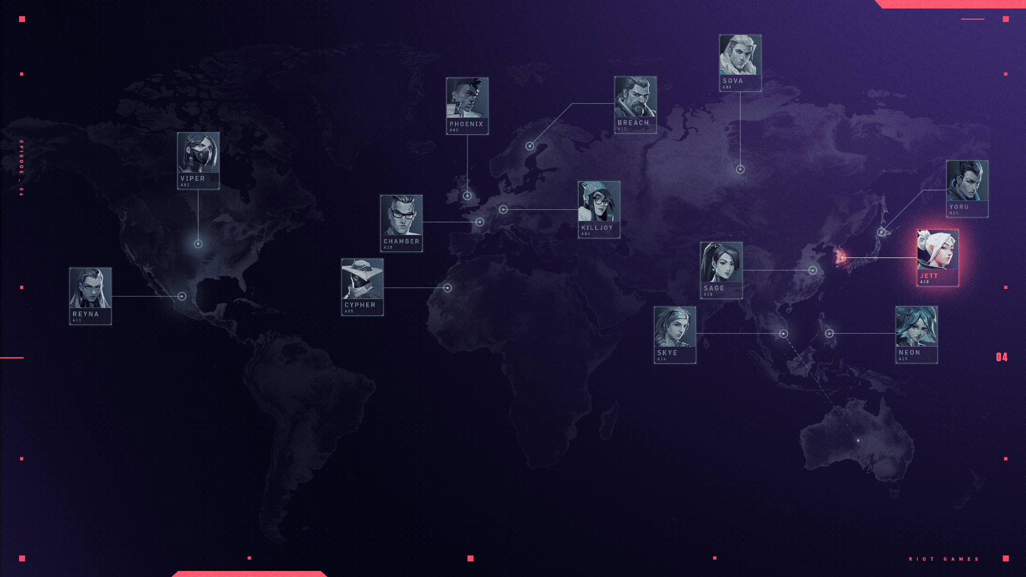

https://valorant.fandom.com/wiki

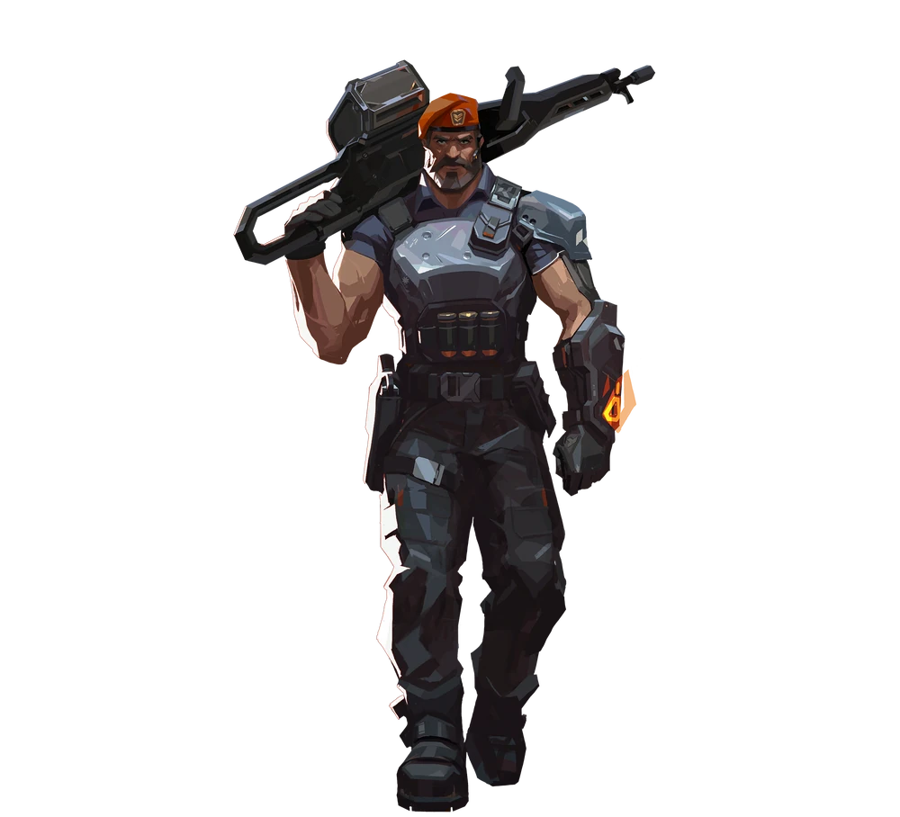

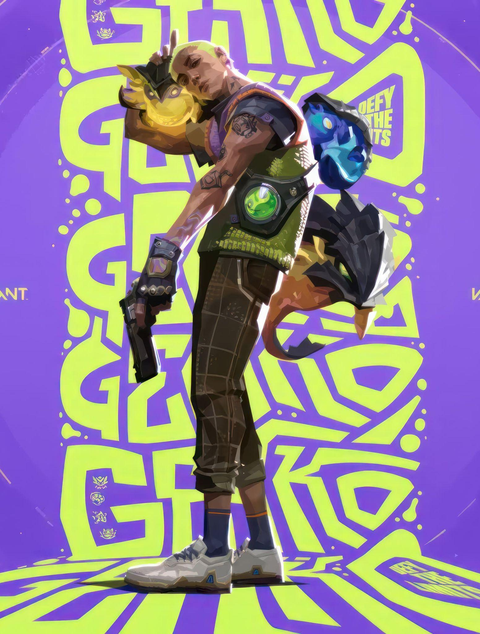 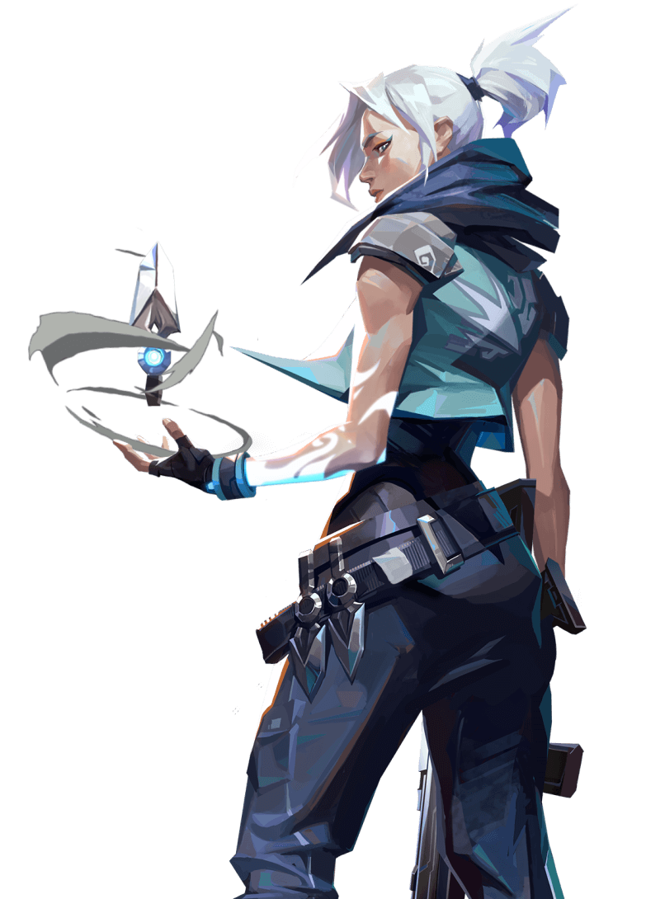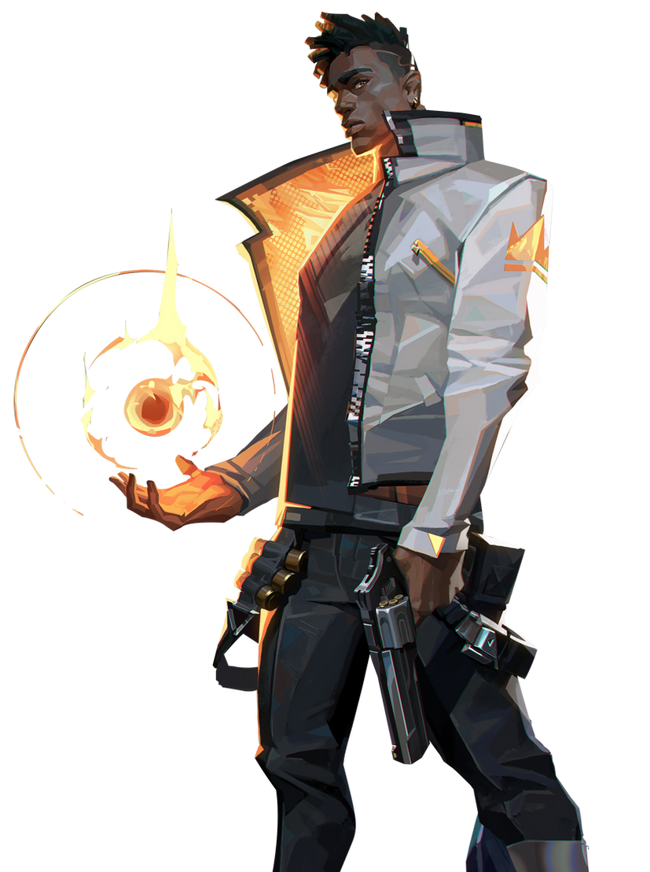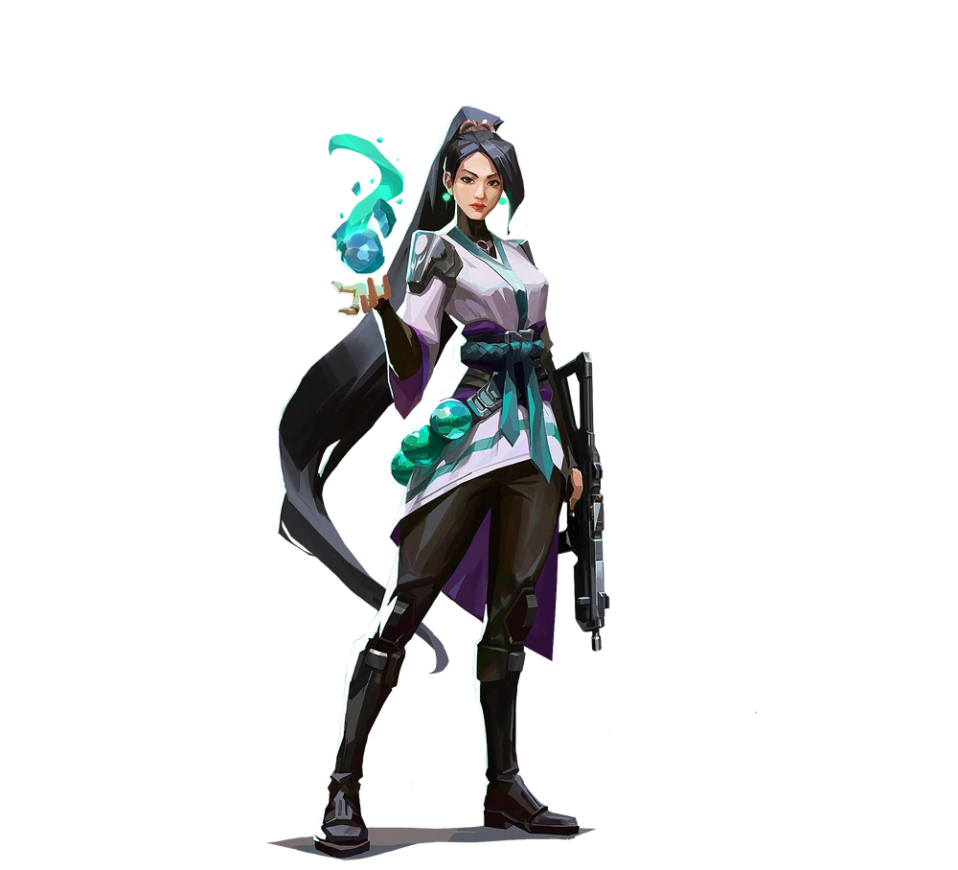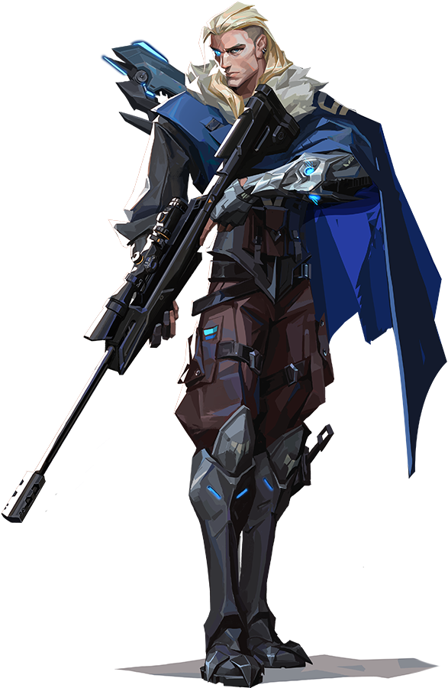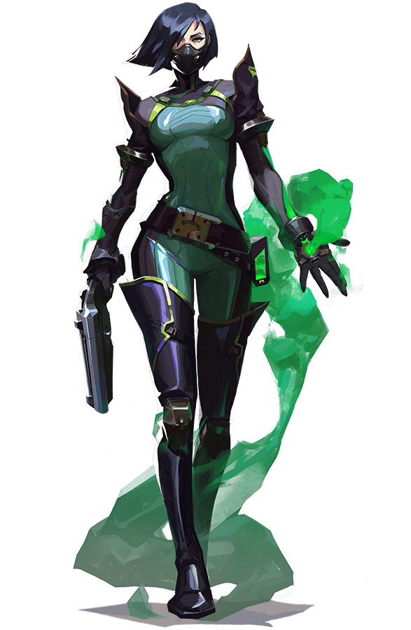

https://www.flaticon.com/free-icons











Bikin sendiri



<https://playvalorant.com/id-id/news/>

 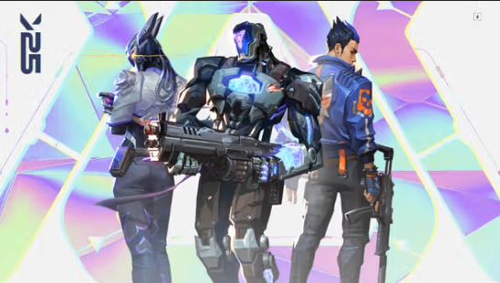 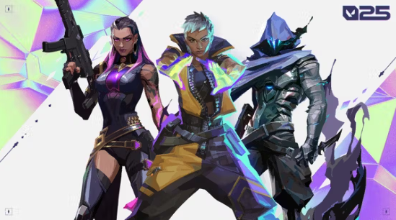

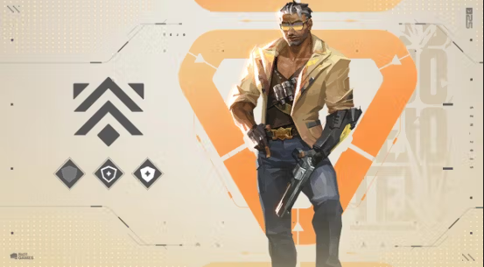 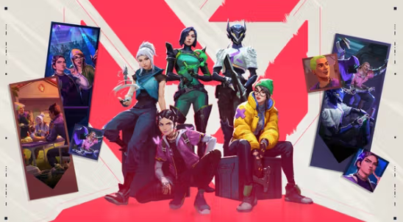 

www.uhdpaper.com

 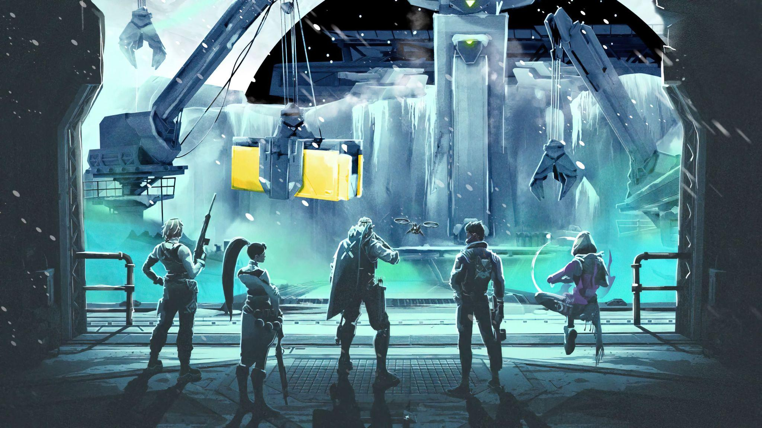

1. Video reference used:

https://playvalorant.com/id-id/

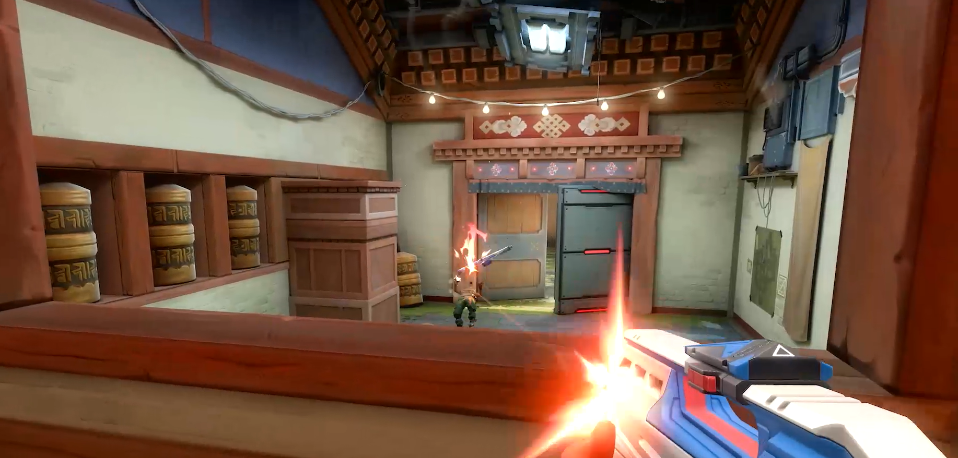

1. Maps Used:

* Ascent change into Ascend

[https://playvalorant.com/id-id/maps](https://playvalorant.com/id-id/maps/)

* Haven change into PIK

[https://playvalorant.com/id-id/maps](https://playvalorant.com/id-id/maps/)

* Breeze change into Bali

[https://playvalorant.com/id-id/maps](https://playvalorant.com/id-id/maps/)

* Bind change into Blind

[https://playvalorant.com/id-id/maps](https://playvalorant.com/id-id/maps/)

* Icebox change into Nepal

[https://playvalorant.com/id-id/maps](https://playvalorant.com/id-id/maps/)

* Split change into Semarang

[https://playvalorant.com/id-id/maps](https://playvalorant.com/id-id/maps/)

1. Agents Used:

* Jett change into Jete

<https://playvalorant.com/id-id/agents/>

* Phoenix change into Phonk

<https://playvalorant.com/id-id/agents/>

* Sova change into Sofa

<https://playvalorant.com/id-id/agents/>

* Viper change into Cobra

<https://playvalorant.com/id-id/agents/>

* Sage change into Sega

<https://playvalorant.com/id-id/agents/>

* Brimstone change into Wilbud

<https://playvalorant.com/id-id/agents/>